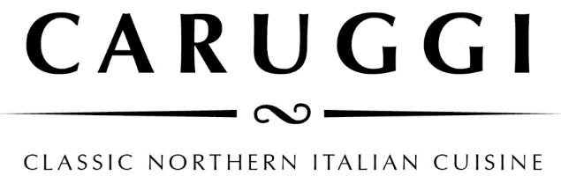

Dinner

**Focaccia col formaggio**

Our speciality which originates from the chef’s hometown of Recco on the Ligurian Coast. This dish has two layers of wafer-thin dough filled with a creamy, tangy handmade cheese then baked in the pizza oven.

The original - Classico

San Danielle prosciutto Pizzata- the classic version sprinkled with capers, olives, anchovies and passata

**Regional Identity - Italian Simplicity**

Massimiliano our owner and chef comes from the region of Liguria, a thin strip of land in Northern Italy where the mountains meet the sea, a cuisine based on fish from the small villages and taggiasche olives and olive oil, herbs and vegetables from the hills. We aim to deliver the simplicity of Northern Italian cuisine using the best of local and Italian produce.

**Buon Appitito**

To indulge in Ligurian cuisine we recommend

Focaccia col formaggio - Mussels - Anchovies - Pesto - Pansotti - Zuppa di pesce

**Buon Appitito**

To indulge in the Ligurian cuisine we recommend

Focaccia col formaggio - Mussels - Anchovies - Pesto - Pansotti - Zuppa di pesce

**Spuntino and Antipasti**

**Mixed Olives** warmed with chilli and herbs 9

**Fior di latte**

with tomato, avocado and spinach Add prosciutto

**White anchovies** on a tomato salad

**Sauteed Portarlington mussels** with fregola, fresh tomato, white wine, and chilli

**Bellarine Smoked Barramundi**

with a caper and lemon dressing

**Daily Terrine**

served with marinated mushrooms

**Bresaola Carpaccio** with parmesan, sorrel, and celery in a lemon dressing

**Salumi Misti** with pickled vegetables and marinated mushrooms

**Secondi**

**Slow roasted** **Duck leg**

with roast potatoes and dutch carrots

**Chianti Braised** **Beef Cheek**

with polenta and sauteed greens

**Daily Fish Livornese style** – pan-fried with olives, pinenuts and cherry tomato in a prawn bisque reduction

Please ask for our daily specials



**Pasta**

**Pansotti con salsa di noci**- handmade pasta filled with silverbeet, herbs and curd served in an Otway walnut pesto

**Pasta al Pesto Genovese**

tossed with green beans and potatoes

**Smoked red pepper Fusilli**

with pork and fennel sausage, broccoli and provolone cheese sauce

**Housemade Pappardelle** al ragu del giorno

**Tagliolini al nero (** freshpasta with **s**quid ink  **)**

With mixed seafood, white wine, herbs, tossed in a lobster bisque

Simple **Spaghetti Napoli**

Classic **Spaghett**i **Bolognese**

**Sides**

Rocket and Parmesan

Tomato, red onion, and basil

Leaves, pear, fresh pecorino and walnuts

Spinach, fennel, and sundried tomato Mushroom and herb polenta with parmesan

Broccolini with toasted almonds

**Pizze**

**Piemontese**

Tomato, mozzarella, ham, mushrooms, and taleggio cheese

Calabrese

Tomato, mozzarella, salami soppressa, red pepper and olives

Valdostana

Tomato, mozzarella, fontina cheese, speck, finished with marinated wild mushrooms

Emiliana

Tomato, mozzarella, finished with prosciutto, rocket and shaved Grana Padano parmesan

**Lombarda**

Tomato, mozzarella, pumpkin, spinach, walnuts and gorgonzola

**Campania**

Tomato, mozzarella, smoked bocconcini, cherry tomatoes and origano

Allergens

Please make us aware of any allergies or dietary requirements when ordering and we can talk you through menu items that will cater to you needs.

Gluten free means no pizza, however most of our pasta sauces can be made with gluten free pasta and the rest of the menu either is or can be adapted for gluten free diners

*A surcharge of 1.8% will be applied to your card transaction*